Abdul Haseeb, Saim Anjum, Laiba Idrees

20F-1066, | BSE-7A

Comparison Report

DevOPs project- task 3

**Tool: Jenkins**

# Findings

Jenkins is a cloud server that provides a facility to build, test, and deploy applications in one go. We don’t have to use different platforms for building, testing, and deploying code just create a job in Jenkins then it will build, test and deploy it on the server.

# Screenshots

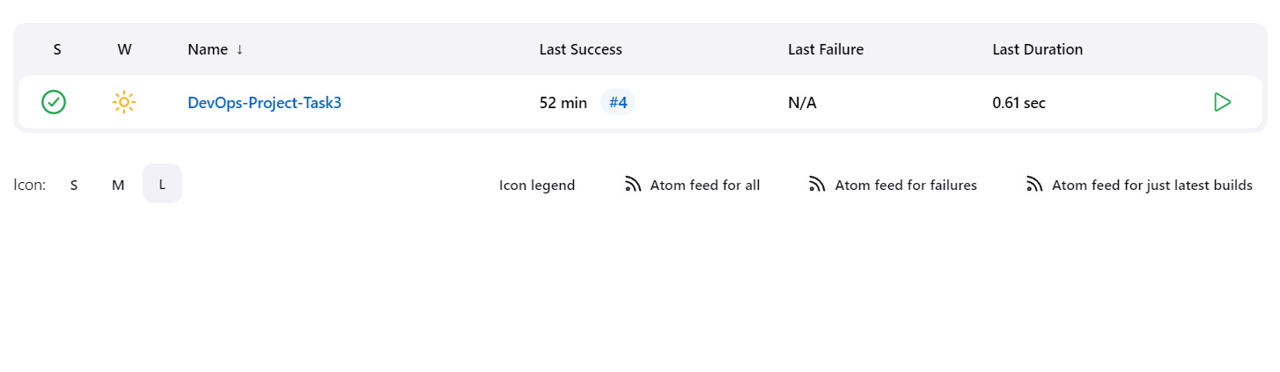

In this screenshot, a job is created in a Jenkins dashboard which is then used to build, test, and deploy the code.

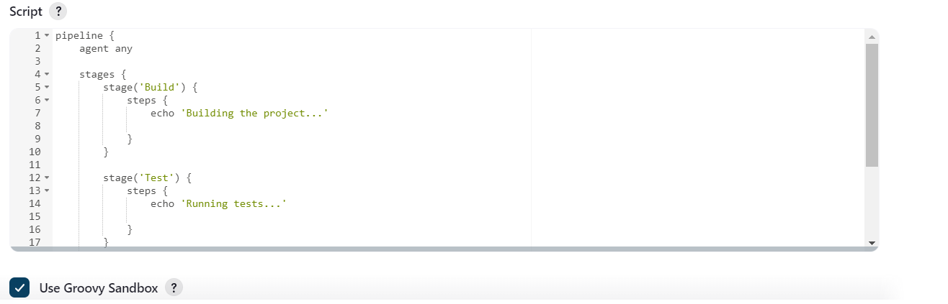

This is a simple pipeline written in groovy language. In this pipeline, simple print statements are coded to check whether the pipeline is built, tested, and deployed successfully or not.

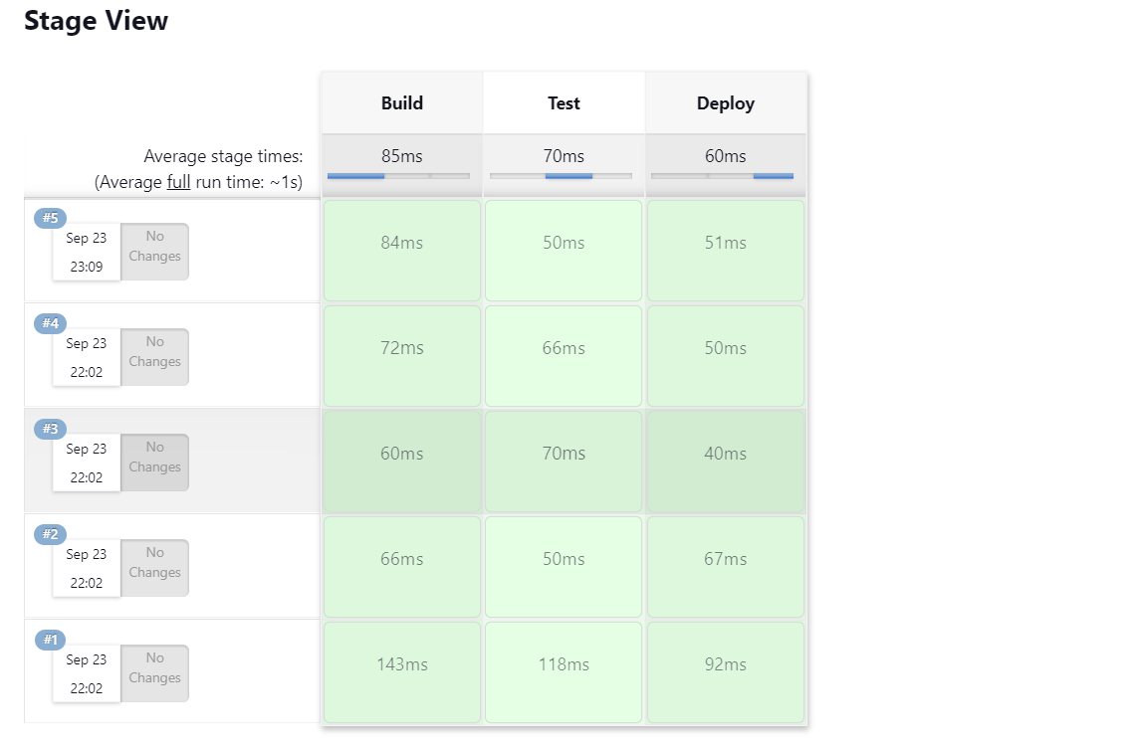

In this screenshot, job is built, then tested, and then finally deployed on the server.

Jenkins is a reliable tool for deploying small to large scale applications as shown as we can easily build, test, and deploy within no time. Also, it is more secure than other deployment servers. For this reason, Jenkins is preferred in most enterprises.

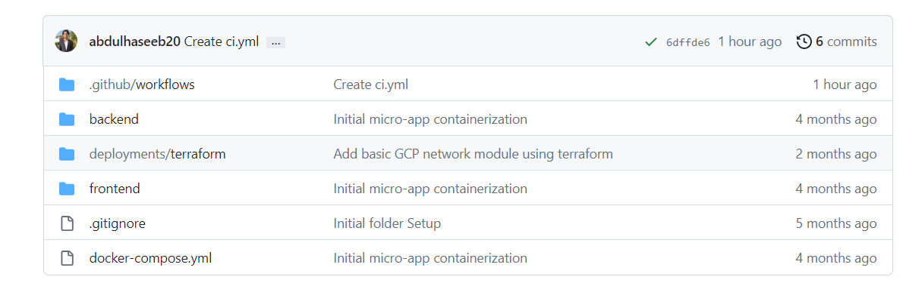

Then, I created a workflow action in the repository provided by the instructor, [Questra-Digital/ts-micro-app](https://github.com/Questra-Digital/ts-micro-app).

Then I created a ci.yml file in which all depenedencies, push, pull requests and jobs are created. Now, just need to run this build.

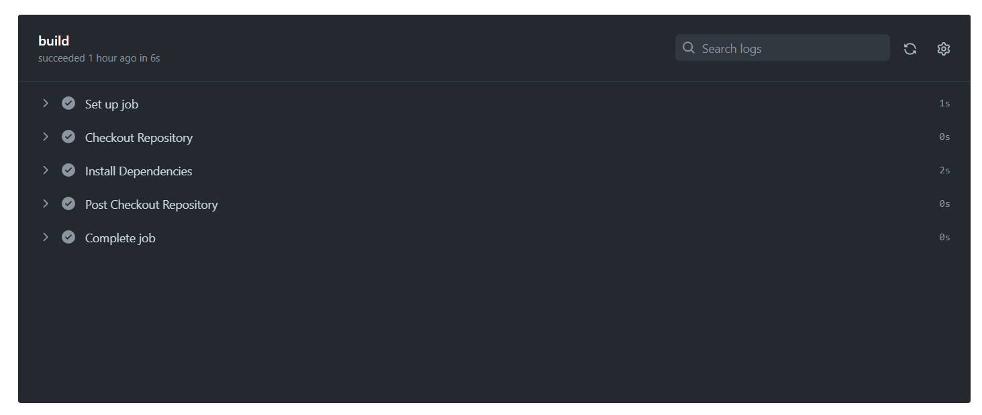

Now as shown above, job is built and all dependencies are created and job is completed.